

PROJECT AND TEAM INFORMATION

Project Title

University Research Paper Repository

Student/Team Information

Team Name: | EduArchive
Team member 1 (Team Lead)  Aayushi Sharma  2318130  230121926  sharmaaayushi953@gmail.com | 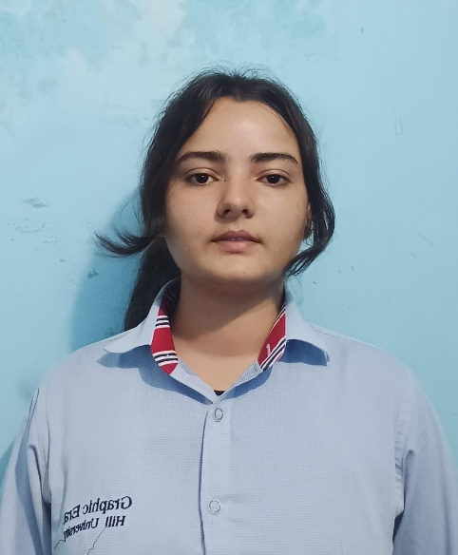
Team member 2  Deepshikha  2318706  230121796  DEEPSHIKHA.230121796@gehu.ac.in | 
Team member 3  Abhilasha  2318150  23011426  abhilashabhatt77@gmail.com | 
Team member 4  Tanuja  2319745  230124746  tanujachuphal7@gmail.com | 

PROJECT PROGRESS DESCRIPTION

Project Abstract

The University Research Paper Repository project aims to centralize and digitize academic research under one accessible system using modern web technologies. Currently, universities face challenges with unorganized and inaccessible research data. This repository provides a systematic interface for storing, reviewing, and retrieving research papers in a secure manner.

Built using Django for the backend and MySQL for the database, the system ensures a structured and maintainable environment for managing research data. Django’s ORM framework simplifies database interactions, while MySQL maintains relational integrity through normalization. The system supports three roles: Admin, Researcher, and Reviewer, each with distinct permissions.

The repository includes features such as metadata tagging, multilingual accessibility, and role-based workflows for paper submission and review. This project enhances collaboration, streamlines research visibility, and preserves institutional academic output at a single, easily searchable point of access.

Updated Project Approach and Architecture
The architecture is a layered Django–MySQL framework following the MVC pattern for modular scalability.
Frontend (Presentation Layer): Developed using HTML, CSS, and Django Templates, integrated with Bootstrap for responsiveness.

Backend (Application Layer): Built in Django, utilizing Python’s flexibility and Django’s built-in authentication and admin tools. The backend handles user management, review workflows, and paper uploads, exposing endpoints through Django Views.

Database (Data Layer): MySQL stores structured data for users, research papers, and reviewer feedback. Tables maintain referential integrity, ensuring accurate role associations.
Communication between layers is achieved through Django’s ORM. Security measures include form validation and CSRF protection. The system also integrates multilingual support via Django’s i18n framework to allow both English and Hindi-based interactions. Version control is maintained through GitHub, ensuring collaborative development workflows.

Tasks Completed
Task Completed | Team Member
- Admin workflow  - Research Interface  - Reviewer Module  - Database Schema Design | - Aayushi Sharma  - Abhilasha  - Deepshikha  - Tanuja

Challenges/Roadblocks
The team faced challenges aligning Django’s ORM models with complex relational MySQL schemas, especially for reviewer-to-paper mapping. Integration of multilingual functionality across form templates initially resulted in encoding and translation mismatches. These were resolved by enabling UTF-8 compatibility and configuring Django’s translation system.

Data synchronization across multiple user roles required transaction-safe database operations. A problem emerged with file size management during uploads, for which Django’s file storage system was optimized and validation checks added. Additionally, managing session states for multiple user logins required refining middleware for role-based access control.

Testing and debugging in the multi-user environment further unveiled race conditions in database access, mitigated by auto-commit disabling and explicit transaction handling. Continuous testing and incremental merging resolved integration inconsistencies.

Tasks Pending
Task Pending | Team Member (to complete the task)
- Integration testing  - Paper submission features  - Search/Filter functionality  - UI testing | - Aayushi Sharma  - Abhilasha  - Deepshikha  - Tanuja

Project Outcome/Deliverables
The final system will be a Django-MySQL web application enabling secure submission, review, and management of university research papers. It provides role-based access with distinct functionalities for Admin, Researcher, and Reviewer. The UI supports bilingual interaction with English and Hindi options for wider accessibility.

Deliverables include a normalized database schema, comprehensive submission and review workflows, and an admin dashboard for oversight. The integrated search facilitates efficient document retrieval, and the cloud backup ensures data durability. This project aims to centralize academic research, prevent duplication, and promote scholarly collaboration within the university.

Progress Overview
Approximately 75% of the project is completed. The major features including user authentication, upload, review modules, and database design are functional within the Django framework. UI implementation and multilingual support are progressing as planned, though UI responsiveness tuning needs completion.

Search functionality and cloud integration are slightly behind schedule but are addressed in upcoming development cycles. Testing is ongoing to ensure bug-free operation. Overall, the project remains on target to meet planned deadlines with deployment slated for next month.

Codebase Information
- Repository: To be shared at submission.
- Branch: main
- Framework: Django (Python 3.10), MySQL backend.
- Structure:
- auth/: User authentication and roles
- upload/: Paper submission and metadata
- review/: Reviewer feedback and approval
- Key Commits:
- db_schema_fix: Schema normalization and migration fixes
- admin_dashboard_v1: Launched admin controls
- Version control via GitHub with peer-reviewed merges.

Testing and Validation Status
Test Type | Status (Pass/Fail) | Notes
Admin workflow module  Research Interface  Reviewer module  Database schema | Pass  Pass  Pass  Pass | User and permission management functional  Submission and upload with metadata active  Review process and feedback workflow implemented  Normalized, relation-complaint MySQL structure

Deliverables Progress
The project deliverables are progressing well with several core components completed and others in final stages. The Admin Workflow module is fully implemented, providing effective user management, role-based access control, and administrative oversight functionalities.
The Research Interface allowing users to submit research papers along with detailed metadata is operational. Similarly, the Reviewer Module supports the entire review process, including assignment of papers to reviewers, submission of feedback, and approval workflows. The underlying database schema has been designed and normalized in MySQL, ensuring reliable and efficient data storage and retrieval.
Work on search optimization using MySQL’s full-text search capabilities is ongoing and will enhance users’ ability to quickly locate relevant research papers. Cloud backup integration for secure document storage is planned for the upcoming deployment phase to ensure data durability and disaster recovery.
The user interface is being polished and tested rigorously across multiple devices and browsers to improve responsiveness and user experience. Overall, the project is progressing as per schedule with key deliverables nearing completion and pending modules targeted for final implementation in the next development cycle.

